Name:__________________________
How to login to Teams?
1. Login to Launchpad through the website: Launchpad.fultonschools.org
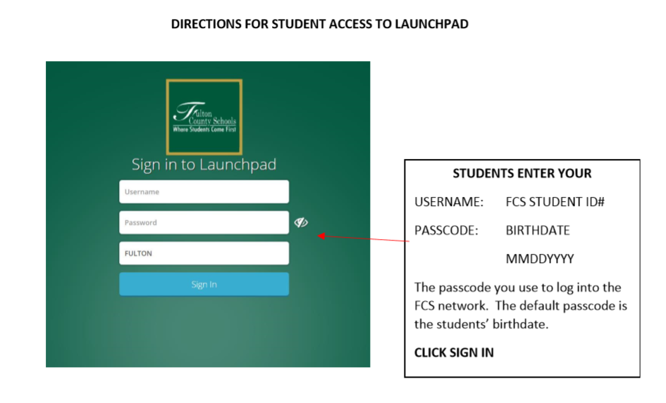
2. Select the Office 365 Icon
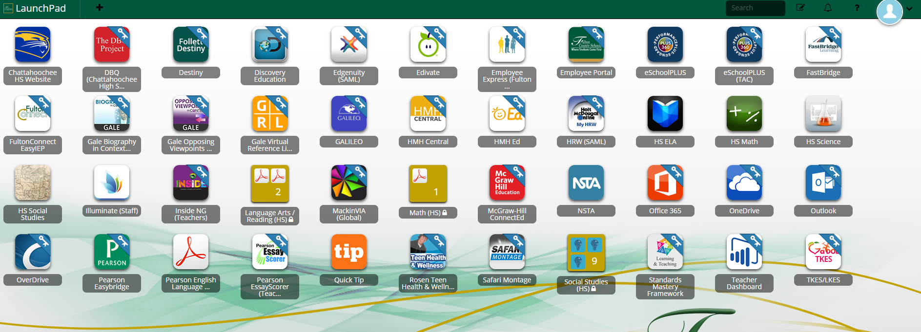
3. Select the Teams Icon
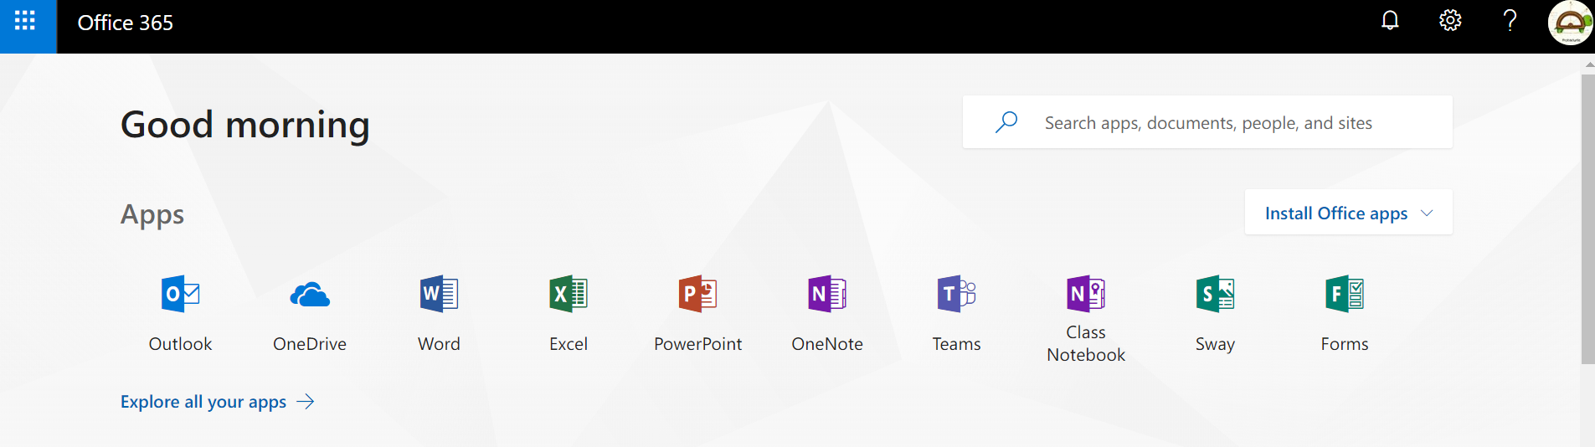

4. Select Join or Create a Team. Then Select Join a team with a code.
Enter the code ______________ to join our class team!
