Midterm Review – Friday 10/12
- Nature of Science (Experimental Design, Scientific Method, Characteristics of Life)
- Ecology (Levels of organization, types of organisms, food webs/trophic pyramids, population ecology)
- Biochemistry (Properties of water & Macromolecules)
I. Nature of Science:
1. What is the difference between an independent and dependent variable? The independent variable is changed/manipulated by the experimenter (what you change), which the dependent variable is what you measure (changes as a result of the independent variable)

2. Identify the Independent and Dependent variable: How does a new vitamin effect the thickness of a dog’s fur?
Independent: Vitamin Dependent: Thickness of Dog Fur

2. What is the difference between a control group and experimental group? ___The control group does NOT receive the independent variable (this group is used for comparison) while the experimental group DOES receive the independent variable.

3. Dr. Washington wants to examine whether cheese increases the maze running performance of rats. Dr. Washington teaches two groups of rats to find a bowl of water in the maze. One group of rats is given the cheese while they are learning the maze. The second group is not given the cheese. One week after having learned the maze he retests the rats and records how long it takes them to find the water bowl.
- Independent variable Cheese
- Dependent variable Time to find the water bowl
- Control Variable Maze
- Control Group Rats w/o the cheese
- Experimental Group Rats w/ the cheese
4. A scientist is studying leaves from different trees. She measures the length of each leaf as well as documents the color. Which data is …
Qualitative color of leaf Quantitative length of leaf
5. Identify the correct characteristic of life in the following scenarios by circling it in the brackets
- A butterfly emerges from a cocoon [ made up of cells / growth and development / heredity ]

- The skin around a penguins eyes allow them to release heat and cool themselves if they are getting to hot [ homeostasis / metabolism / reproduction ]

- A cactus plant grows towards the light [ heredity / response to environment / need for energy ]

- Before a track meet, the student ate a large carb loaded dinner [ reproduction / heredity / need for energy

II. Ecology
- Which level of organization includes…
  - A group of the same species in a given area population

  - Trees, birds, rocks and temperature ecosystem

- Circle all the types of organisms that apply to the following scenario: Organisms that make their own food using chemicals, like sulfur can be classified as…?
[ consumers / producers / autotrophs / heterotrophs / herbivores ]
- Does photosynthesis [ remove / release ] carbon dioxide in to the atmosphere?

- In the nitrogen cycle, bacteria remove nitrogen from the atmosphere to make it usable through [ nitrogen fixation / denitrification ] and bacteria release non-usable nitrogen back to the atmosphere through [ nitrogen fixation / denitrification ]

- In the water cycle, water is returned to the Earth through [ evaporation / precipitation ] and returned to the atmosphere through [ evaporation / precipitation ]

- For the following terms write if the organisms are + (benefitted) – (harmed) or 0 (neither helped nor harmed)
  - Mutualism: +/ +

  - Commensalism: + / 0

  - Parasitism + / -

- Examples of density-dependent limiting factors are competition or predation, disease and examples of density-independent limiting factors are severe weather!

- Draw the 2 types of population growth: exponential and logistic growth.
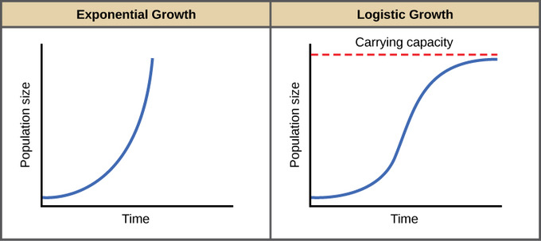

- Succession is the process of creating a healthy ecosystem [ population / ecosystem ], the difference between primary and secondary succession is that primary succession does not start with soil but only bare rock. Both types of succession have pioneer species, which are the first species to colonize the area.

III. Biochemistry and Macromolecules
- After a long run, Sophia mixes lemonade mix into a glass of water to make lemonade. Identify…

A. Solutelemonade mix B. Solvent water C. Solution lemonade

- If something is nonpolar, like oil, it will only dissolve other [ polar / nonpolar ] solutes.

- Water sticks to other water molecules because of [ cohesion / adhesion ], water sticks to paper towels because of [ cohesion / adhesion ]

- If something has a low pH it is very [ acidic / basic ], if something has a high pH it is very [ acidic / basic ]

- Carbs have a 1:2:1 ratio; therefore, if a carb has 15 C it has 30 H and 15 O

- Which would you rather use for short-term bursts of energy [ carbohydrates / lipids / proteins ]

- For each macromolecule, identify the monomer, polymer and function:
Carbohydrate
Monome rmonosaccharide Polymer: polysaccharide Function short term energy
Lipid
Monomers glycerol & 3 fatty acids Polymer Lipid Function Long-term energy, membrane structure Example waxes, fats, oils, hormones
2 types of fats: Saturated Fats come from [ plants / animals ] and are [ solid / liquid ] at room temperature
Unsaturated Fats come from [ plants / animals ] and are [ solid / liquid ] at room temperature
Protein
Monomer amino acid Polymer protein Function structure/regulating reactions
Nucleic Acid
Monomer nucleotides Polymer nucleic acids Function store/transmit genetic information

**Note: Midterm can cover any concept within the 3 main units. Use guided notes as additional study guide resource! Guided Notes/PowerPoints are posted on my website!**

